# Lab 4 – SID, PowerShell

# Task 1: Getting SID, SAT on Windows

* Obtain the SID of the current login with **WMIC** command. Attach a screenshot for the SID and highlight it in red/yellow.

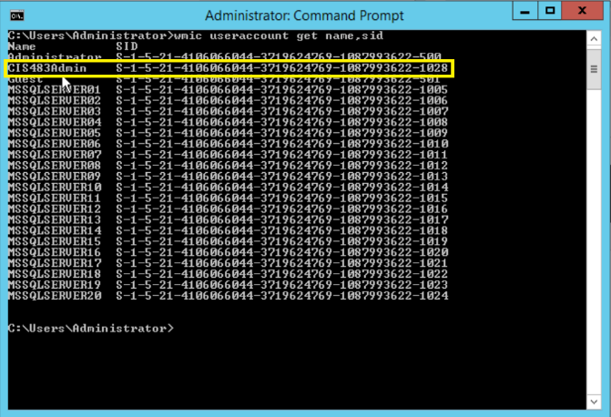

* Obtain the SID of the current login in the Registry. Attach a screenshot for the SID and highlight it in red/yellow.

# Task 2: Getting SID on SQL Server

Get the SID of the account you used for SQL Server login.

A. SID: ____________________________________________.



B. What is the role of the function “fn_SIDToString” in the above?

* Takes the SID and converts it into string format

C. Compare the SID from SQL Server for the administrator login with that from Windows Server for the administrator. Show the two screenshots. Use the SIDs in a string format (that is, in the S- format, not in Hex). Are they the same?

The SID of the administrator login from SQL Server (show the S-format)

The SID of the administrator login from Windows Server (show the S-format)

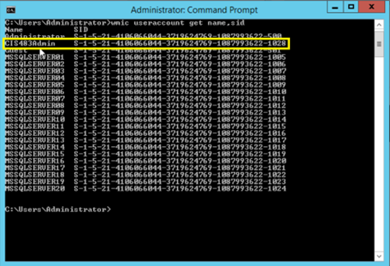

D. SID: _________________________________________.

E. SID: _________________________________________.

F. Are the SIDs of login SIDTest the same? Describe the reason why they are (not) the same?

* No because the SID refers to one unique user account as it is used to verify that specific account.

# Task 3: Learn PowerShell Scripting

* Run your script and report the output in a screenshot.

